# Table of contents

**1. INTRODUCTION**1

**2. Database Design**2

2.1 Entity relationship diagram 2

2.2 Data dictionary 2

**3. Interface design**4

3.1 Login Page 4

3.2 Dashboard page 5

3.3 Dormitories page 6

# List of Tables

Table 1: Data dictionary 2

# List of Figures

Figure 1: Entity relationship diagram 2

Figure 2: Login page 5

Figure 3: Dashboard page 6

Figure 4: Dormitories page 7

# List of Abbreviations

DCMMS: Dormitory Cleaning Materials Management System

# 1. INTRODUCTION

A dormitory cleaning material management system is a system that is going to ease how patrons/matrons/students manage the dormitory cleaning material.

# 2. Database Design

## 2.1 Entity relationship diagram

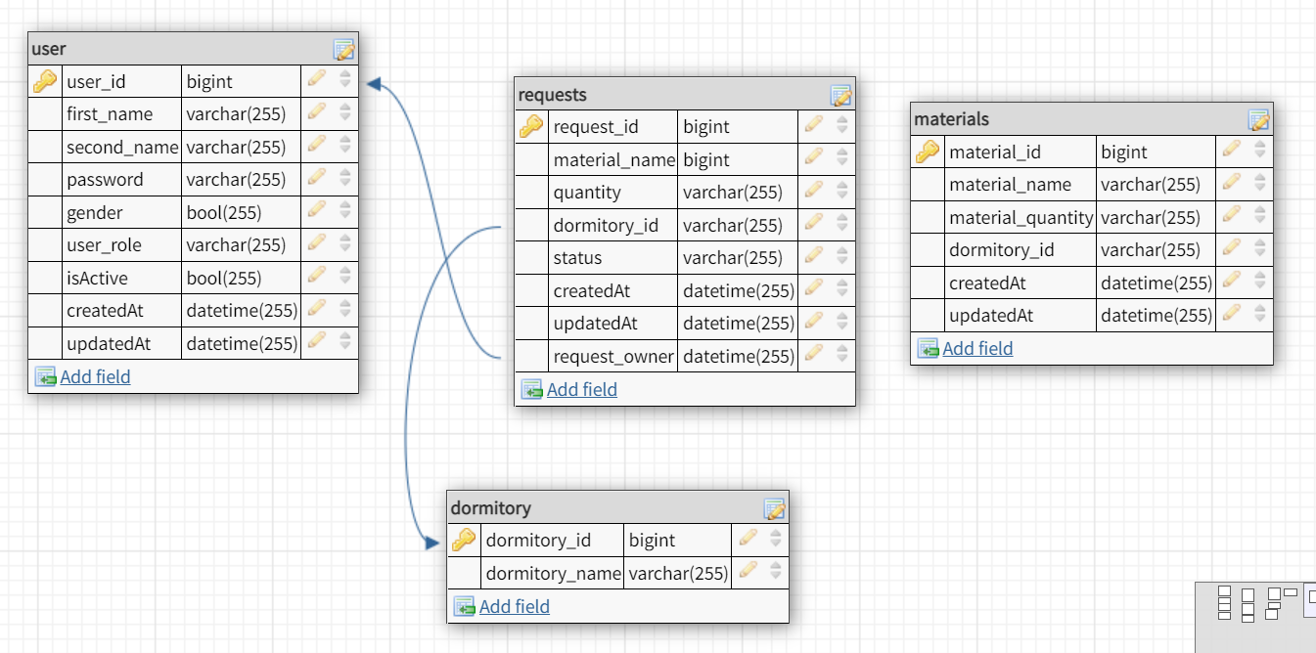

Figure : Entity relationship diagram

## 2.2 Data dictionary

Table : Data dictionary

|  |  |  |  |  |  |  |
| --- | --- | --- | --- | --- | --- | --- |
| # | Entity name | Field name | Data type | Length | Constraintns | Description |
| 1 | user | id | big integer | 10 | Primary key | User’s identifier |
| username | varchar | 255 | * Unique * Not null | User’s account |
| password | varchar | 255 | Not null | User’s password |
| email | varchar | 255 | Null | User’s email |
| first_name | varchar | 255 | Not null | First name |
| last_name | varchar | 255 | Not null | Last name |
| phone_number | varchar | 255 | Not null | User’s phone number |
| 2 | Dormitory | dormitory_id | big integer | 10 | Primary key | Dormitory’s identifier |
|  | dormitory_name | varchar | 255 | * Not null * unique | Dormitory name identifier |
| 3 | material | material_id | big integer | 10 | Primary key | Material identifier |
| material_name | varchar | 255 | * Not nul * required | Material name identifier |
| material_quantity | integer | 10 | * Not null * required | Material quantity identifier |
| dormitory_name | varchar | 255 | * Not null * Required * Foreign key | Dormitory name identifier |
| 4 | requests | request_id | Big integer | 10 | * Primary key | Request identifier |
| material_name | varchar | 255 | * Not null * required | Material name identifier |
| quantity | Integer | 10 | * Not null * required | Quantity of material identifier |
| dormitory_name | varchar | 255 | * Not null * required | Dormitory name identifier |
| status | varchar | 10 | * Not null * required | Status of the request identifier |
|  |  |  |  |  |  |  |

# 3. Interface design

This is the sample of some pages in DCMMS but the rest of the pages can be found here:

[DCMMS – Figma](https://www.figma.com/file/Rek8hKee3KJvBBmxdnyPJT/DCMMS)

## 3.1 Login Page

The page that every user will log in through

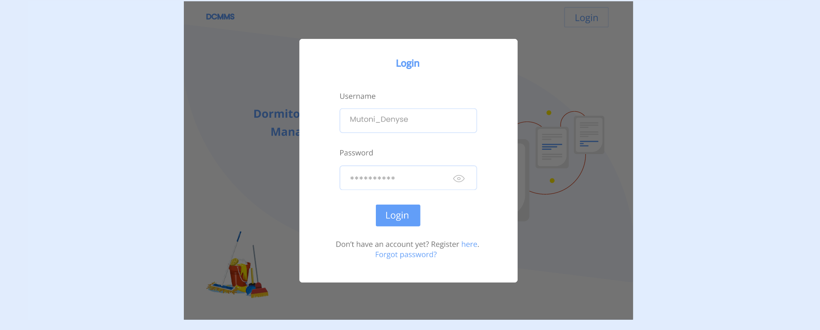

Figure : Login page

## 3.2 Dashboard page

A dashboard page that shows all the tools/materials and the logged in user can filter according to what she or he wants.

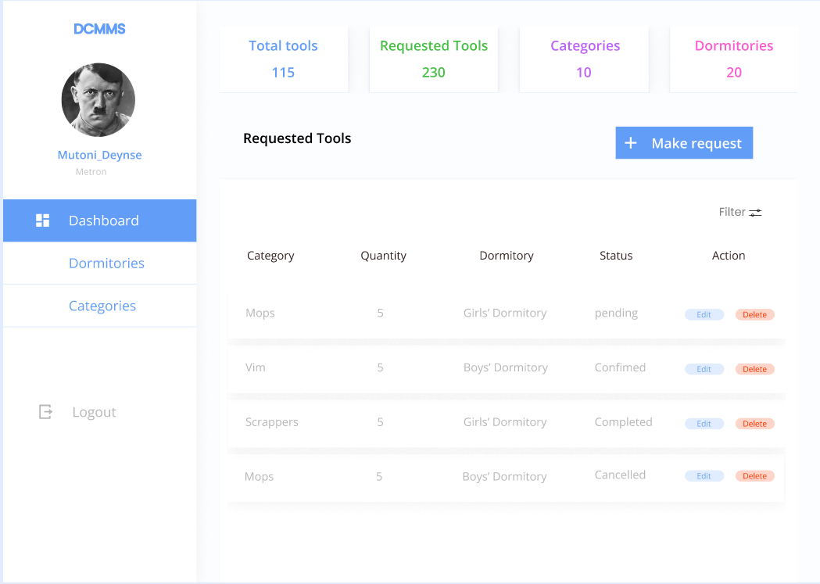

Figure : Dashboard page

## 3.3 Dormitories page

The page that shows dormitories according to and materials per dormitory.

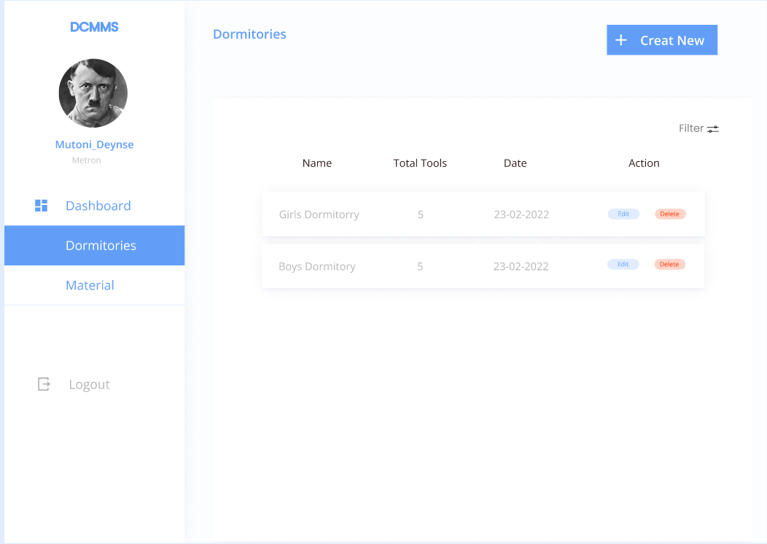

Figure : Dormitories page